Think Central https://www-k6.thinkcentral.com/ePC/start.do
Login with student username and password
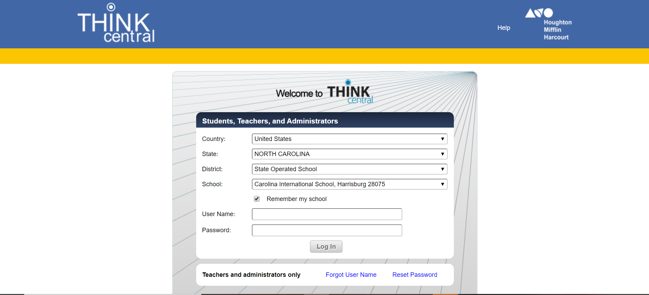

To access the Student assignments:
- Things to Do Click on the Reading and Mathematics assignments (in blue)
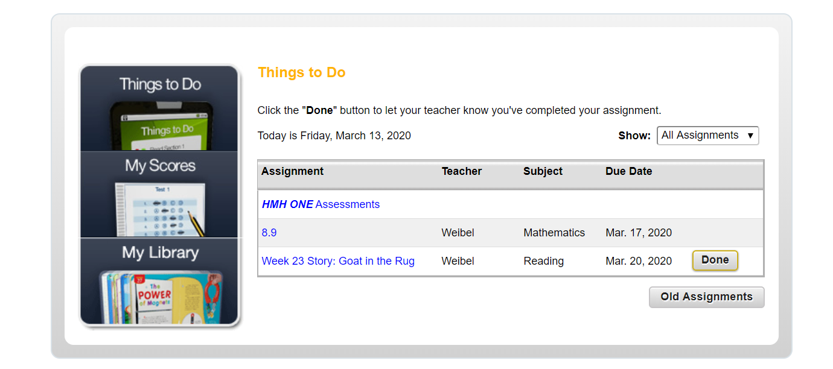

To access all the Go Math student videos:
- My LibraryMathematicsGO Math Interactive Student EditionClick the Chapter and then the Lesson to view video
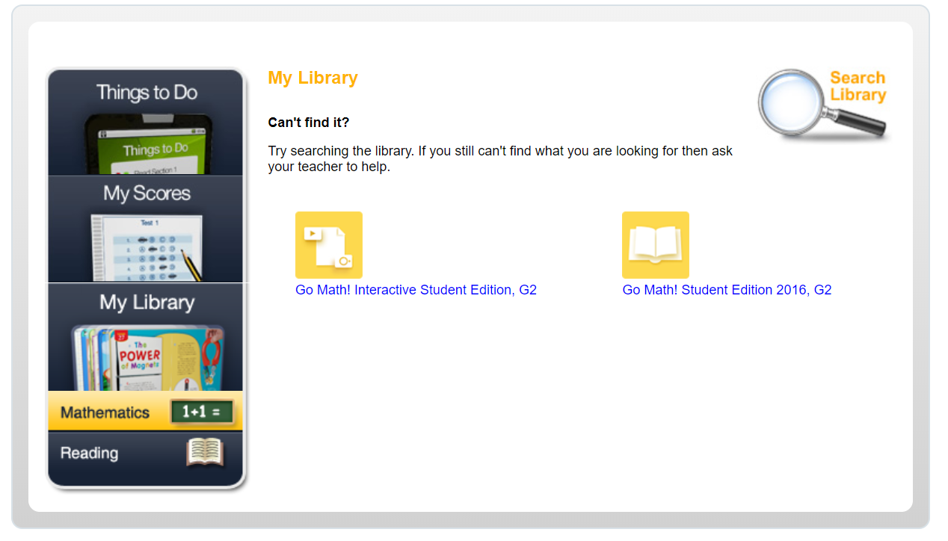
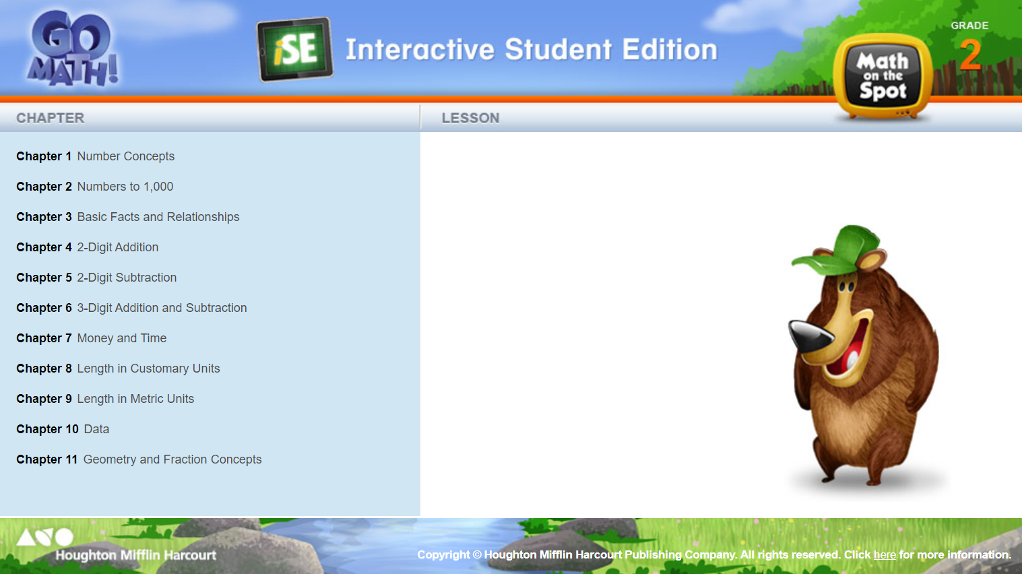

To access the Journeys student textbook with the story of the week:
- My LibraryReadingStudent EbookBook 2Contents Unit 5 Click on the Lesson and then the name of the story
